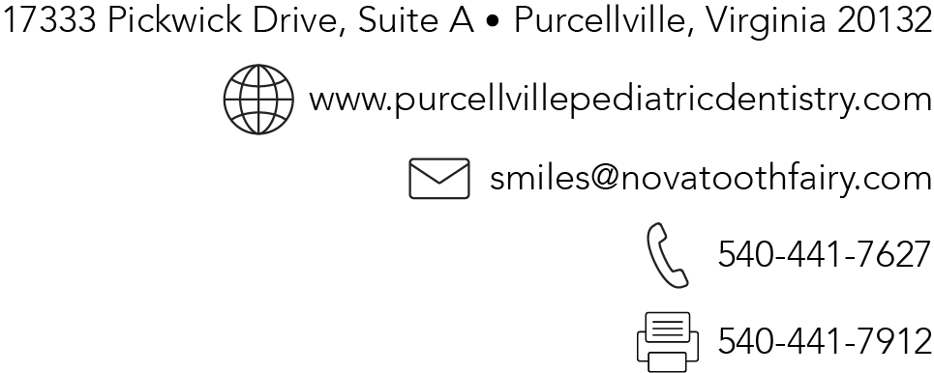
CONSENT TO RECEIVE TELEDENTISTRY SERVICES

Patient Name
What is a teledentistry consultation?
Teledentistry is a means of delivering dentistry to patients outside of the traditional office setting. Teledentistry may utilize digital scans, photographs, images, dental records, and other history information to provide recommendations for your dental care. Depending on the goals of the visit and information available to the dentist, a teledentistry consultation may require more than one visit.
What happens during a teledentistry consultation?
The dentist will collect electronic dental records and perform an examination of your mouth. The dentist will record his or her findings and discuss recommendations for your dental care. In some instances, your dentist may discuss confidentially your personal health information with another health professional by phone call or other communication technology.
What are the risks, benefits, and alternatives to teledentistry?
Teledentistry is not a substitute for in-person dental treatment. It is a means to, monitor ongoing care, have access to dental information, and discuss treatment and care options with a dentist without having to physically present to an office. In some instances, an in-person visit to a dental office may be necessary even after a teledentistry consultation because of a specific medical or dental condition, or for other reasons. Your dentist will discuss recommendations for future care at the conclusion of your teledentistry consultation. The alternative to a teledentistry consultation is an in-person visit.
Confidentiality
Current federal and Virginia laws concerning confidentiality apply to your protected health information used or disclosed in the course of your teledentistry consultation. You will be required to sign a separate document informing you how your private information is handled.
Rights
You may choose not to participate in a teledentistry consultation at any time before or during such consultation. If you choose not to participate, it will not affect your right to seek or receive future care or treatment. You have the right to seek in-person treatment at a dental office at any time before or after your teledentistry consultation.
My dentist has discussed with me the information provided above. I have had an opportunity to ask questions about this information, and all my questions have been answered. I agree to have my records, including digital scans, X-rays, photographs, charting of conditions, and other health history information collected from me and shared pursuant to the laws of the Commonwealth. I acknowledge that no guarantee or assurance has been made regarding the care I have authorized and received.
By signing your name below you acknowledge that you have read and understand the information stated above and that you give consent for teledentistry:

Signature of Patient’s Parent/Legal Guardian Date

Printed Name of Patient’s Parent/Legal Guardian

